My best friend
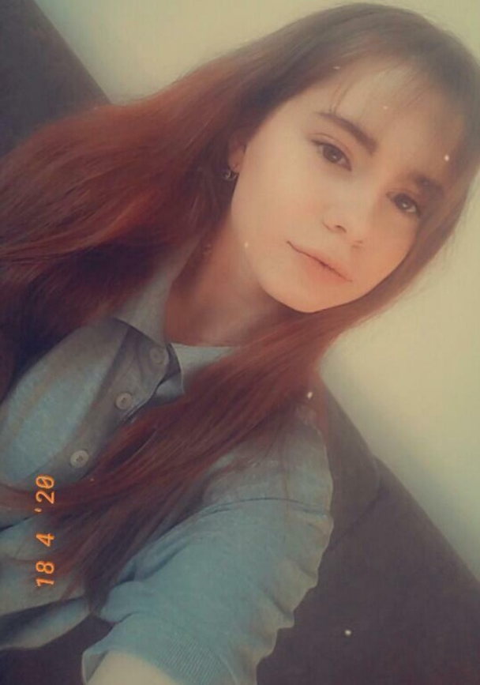
These days, good friendships are hard to find. I think you need to have common interests, similar personalities and something you can easily talk about. My best friend's name is Antonija and I'm so glad that I have her in my life. She is kind, funny and we get along very well. She has long brown hair and brown eyes.
Antonija goes to music school, she plays the flute, but she can also play the piano. She is really musically talented, not just in playing instruments, but also in singing and dancing. I think she's pretty fashion conscious and could spend hours in front of her mirror, picking out a perfect outfit and putting on matching makeup. It's strange how we are now best friends because we didn't even talk that much in the beginning. I guess we just kind of connected since we both started liking the same type of music. We've known each other for a long time, I think even more than 10 years, but we didn't start hanging out until a few months ago. Antonija is so easy to talk to and I can tell her everything because I know she will keep it as a secret. She has helped me so much this year and I hope I did the same for her. My best friend is the person on whom I can truly count on. Whenever I need help or support, she is always there for me. A best friend should be understanding. You should be able to share anything with them without the fear of being judged. They should be supportive and encouraging of one another. My best friend and I are a team. We struggle together, we fight together and we save each other.
I feel one of the main reasons why I formed such a bond with Antonija was because of the qualities she possesses. Her courage always inspired me. Above all, I feel the quality that appeals to me the most is her compassion. She won't hesitate to help someone in need.
When I consider all these things , my best friend has helped me to become a better person. If you are able to find someone like that, it is perhaps, the greatest joy in the world. The mutual understanding and honesty which can be shown by your best friend cannot be done by anyone else in the world. Antonija and I spend most of the time together doing the things we like to do. We enjoy our life according to our needs and wishes.
