Teenagers and their time
Most teenagers have very different schedules and things they like or want to do. Also, there is a big difference between girls and boys. Some have a lot of activities, but some have none or very little. The ones that have a lot of activities mostly have them at school, others don’t have a lot of activities and have them at home. Schools offer a lot of different and interesting activities.
Some teenagers consider sleeping as an activity and they also play video games while others have sports like basketball and football. Most teenagers are very active in things they are interested in, some take robotics because they like programming or they want to become engineers. The difference between girls and boys is the fact that boys are sometimes very lazy. That’s why girls will take more activities than boys and they will probably be more intellectual like drama club or extra math classes. If boys must choose, they will take up something like sport or something where other boys go because they mostly stick in packs. Teenagers often hang out at cafes or places like that and spend their free time there. Of course, there are exceptions but it’s mostly like this. And all this is nothing like before. Before people were spending more time outside and with their friends playing and not drinking coffee but today it is more like this.
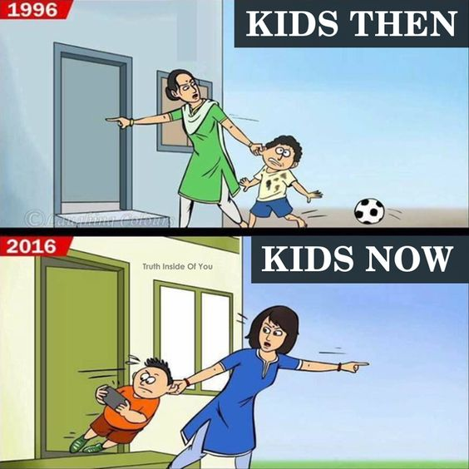
Technology is mostly responsible for that because people want to stay at home and watch TV or play video games. Times have drastically changed and as time passes by they will change even more. In the future people might not go outside at all, maybe there won’t be any outside. We might live in a computer world just like the Matrix. Our parents knew how to play many games but nowadays children simply don’t know how to play with anything except computer games. That’s also why technology is our future but probably our doom.
I think that parents should get more involved about this because they can show us how they played and what they played with. Also, parents should teach their children to play outside, not just give them a phone and ask to leave them alone. We should all spend more time playing, enjoying and breathing fresh air.
My conclusion is that we should be outside more and that parents should be an example of that. I would really like if my dad showed me how he played before and I think every child would like that so that’s one solution for the problem but there are always many more. Teenagers should be thought to live their lives with technology but not letting technology rule their lives.

DOMINIK BELINIĆ, 8.b

