My best friend
Someone said : “Friendship is a great blessing in everybody´s life and friends are the family that we get to choose.“ I have so many friends but it is very difficult to find and keep a special person who understands you and who will stay by you through your good times and bad times. I`m so lucky that I have that special person in my life, a person who makes me smile no matter what.
She has been my friend since childhood. We came to kindergarten together, we grew up together and we both go to the same school. We have been in the same class since the fifth grade and for the last two years we became inseparable. Through these years we found out that we have so many things in common. She knows everything about me, my secrets, my fears, my problems. We confide to each other. I can share everything with her, without fear of being judged, even when she doesn´t agree with me. We have our internal jokes and language. Our friends are always confused when they see us talking without saying a word. This year was very difficult for me and I had a really hard time in my life because my parents got divorced. Through that time, I was in a mess and she was there for me. She was a support and comfort to me.
We do almost everything together and we know each other so well. Often, we study together and help each other with schoolwork. In our spare time we communicate through texting and face miming. Sometimes we talk for hours about films, music and other things we like. People who say that best friends are like family members, are right because we like to call each other sisters from another misters. Like sisters we sometimes get angry on each other, but those moments rarely occur, and we always solve our problems. She helps me to become a better person, more tolerant and less stubborn. She thought me how to deal with my problems. My best friend Lora is the nicest and the most emotional person I know. I don`t like seeing her crying because then I´m also sad.
Lora has an important place in my life and I´m very thankful for our friendship. I hope that we will go to the same high school. Also, I am hoping to see her getting married someday. I`m so happy to know that I have such a beautiful and amazing best friend. I love her to the moon and back and I thank God every day for sending her into my life.

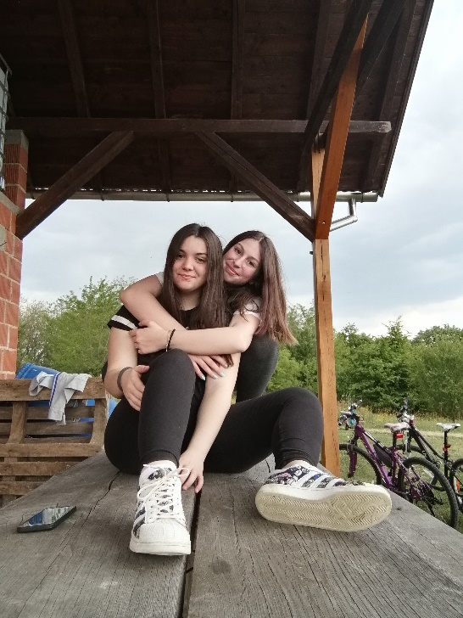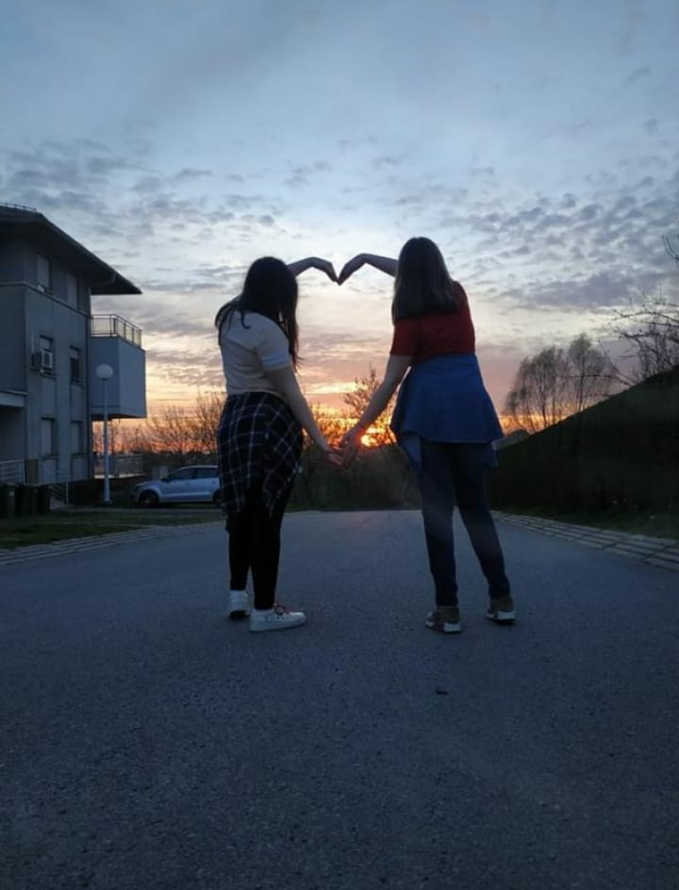

EMA ŽLOF, 8.b

